INTRODUCTION:
Free vibration is a vibration in which energy is neither added to nor removed from the vibrating system. It will just keep vibrating forever at the same amplitude or a structure is said to be undergoing free vibration when it is disturbed from its static equilibrium position without any external dynamic excitation.
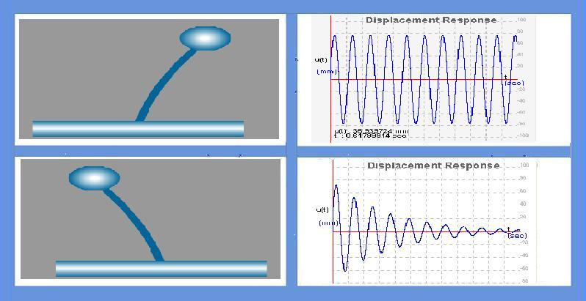
THEORY:
Free vibration is initiated by disturbing the system from its static equilibrium position by imparting the mass some displacement u(0) and velocity u’(0) at time t=0.
There are two cases in free vibration
1. undamped free vibration
2. damped free vibration
Undamped free vibration :
The governing equation for undamped free vibration is
where,
m = mass ,u'' = acceleration, k = stiffness, u = displacement.
The solution to homogeneous equation is :
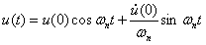
where,
u(0) = initial displacement ,u'(0) = initial velocity.
Here in this solution we can observe that the system will vibrate only if initial displacement and/or initial velocity is given.
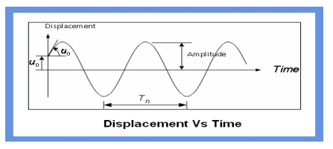

Damped free vibration :
The governing free vibration of the SDF system with damping

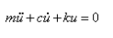
where,
c = damping coefficient , u' = velocity coefficient

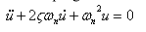
where ω n = natural frequency

OBJECTIVE:

To understand the behavior of single degree of freedom system vibrating with initial excitation (i.e, initial displacement and/or initial velocity and with or without damping).
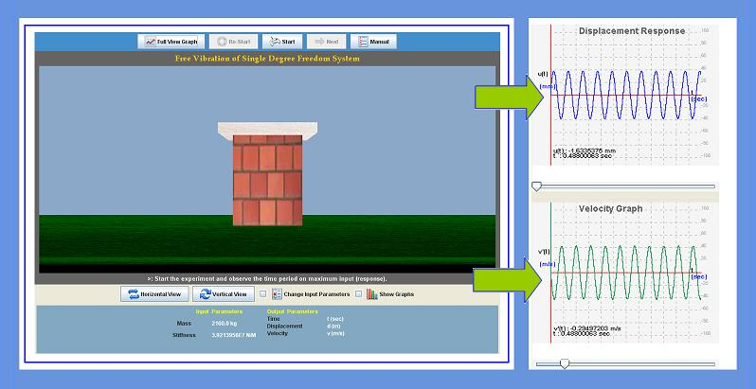
MANUAL:

Start the experiment with some default values of initial displacement (u=10mm) and initial velocity (v=5m/s). and zero damping. Pause the experiment after a few cycles.

Observation 1:
1. Observe the time period (T) and amplitude.
2. Again start the experiment freshly, this time modifying the values of initial conditions.
3. Observe that the time period is independent of initial conditions.

Observation 2:
Effect of structures properties on time period
1. Modify the value of mass and obser
2. Run the experiment for different values of mass and note the time period every time mass is changed
3. Draw the graph between mass and time period.
4. Repeat the same with stiffness.
5. Change the structures stiffness (i.e., change time period.
6. Run the experiment for different values of stiffness and note the time period every time stiffness is changed.
7. Draw the graph between stiffness and time period.
8. Again start the experiment this initial conditions.

Observation 3:
1. Add damping to the system (i.e., 5%) and run the experiment .
2. Observe the effect of damping on time period and amplitude.
3. Run the experiment for different values of damping is changed.
4. Draw the graph between damping and time period.

Observation 4:
1. Add damping to system (i.e., 5%) and run the experiment.
2. Run the experiment and stop after few cycles.
3. Note the values of displacement on consecutive troughs and check the value of damping by logarithmic decrement formula..

PART - 2
ANIMATION STEPS
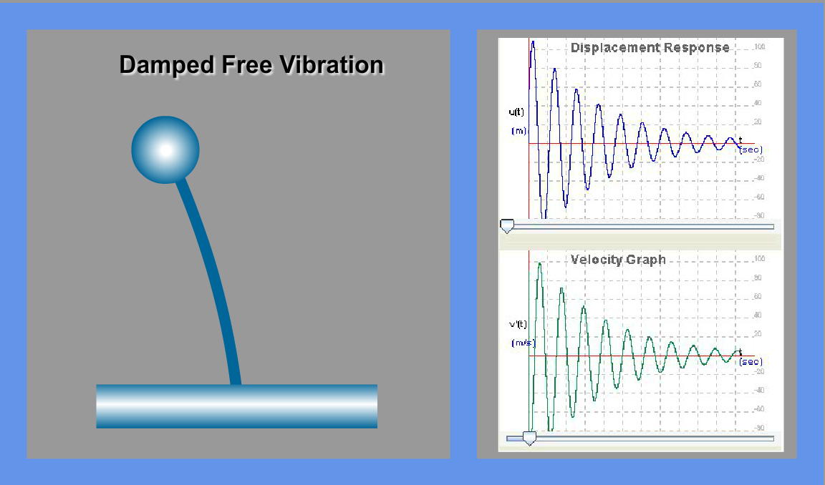

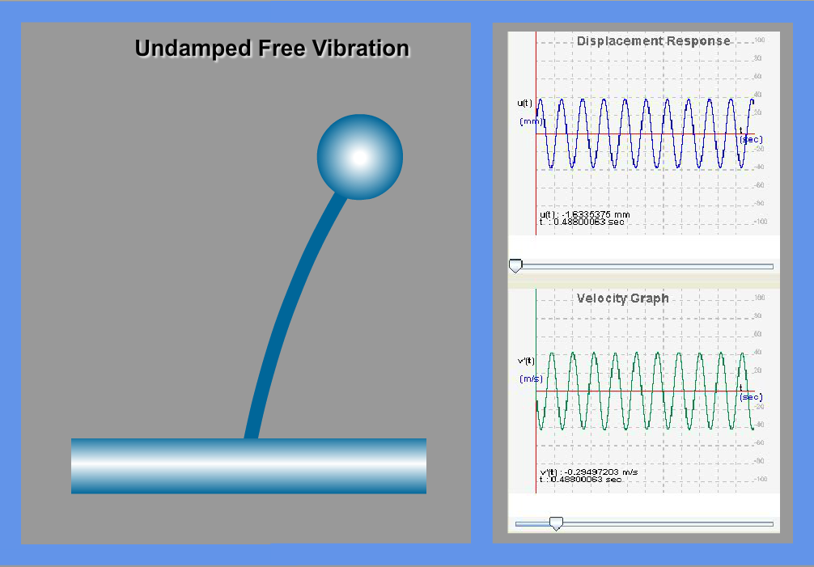

PART – 3
VIRTUAL LAB FRAME
